**Introduction**

**Project Title:**

**Pattern Sense: Classifying Fabric Patterns using Deep Learning Team Members:**

* **Team ID:** LTVIP2025TMID20355

# Team Size: 4

* **Team Leader:** Murari Sowmya
* **Team Member:** Mohammad Shaheen Tabussum
* **Team Member:** Mohammad Haleema Sadiya
* **Team Member:** Muppidi Chaitanya Sai

# Project Overview Purpose:

The purpose of *Pattern Sense* is to automate the identification and categorization of fabric patterns using advanced deep learning techniques. The system streamlines pattern recognition tasks in industries such as fashion, textiles, and interior design.

# Features:

* **Automated Pattern Classification:** Accurately classify different fabric patterns, including stripes, polka dots, floral prints, and geometric designs.
* **Quality Control:** Detect irregularities or defects in fabric patterns, ensuring high-quality production.
* **Efficient Pattern Selection:** Quickly identify and select suitable patterns to match design concepts.
* **Industry Applications:** Designed for fashion, textiles, and interior design workflows.

# Skills Required:

* Python for implementing the model
* Data preprocessing techniques for preparing datasets
* TensorFlow for deep learning development
* Deep learning model design and fine-tuning

# Scenarios:

**Scenario 1 – Fashion Industry:**

* Automate pattern categorization to save time and effort.
* Enhance design and manufacturing by quickly identifying suitable fabrics.

# Scenario 2 – Textile Quality Control:

* Detect defects and irregularities in patterns.
* Improve accuracy and reduce manual inspection time.

# Scenario 3 – Interior Design:

* Efficiently select fabric patterns matching design themes.
* Streamline project workflows.

# Technical Requirements:

* **Programming Language:** Python
* **Deep Learning Framework:** TensorFlow
* **Data Preprocessing:** Image processing and augmentation

# Potential Benefits:

* Increased efficiency by reducing manual work.
* Improved accuracy in pattern classification and defect detection.
* Enhanced quality control in production and distribution.

# Architecture

The *Pattern Sense* system architecture consists of the following components:

# Data Preprocessing Module:

Load, clean, and augment the fabric pattern dataset.

# Model Training Module:

Build and train deep learning models using TensorFlow and Keras.

# Pattern Classification Module:

Predict pattern classes for new fabric samples.

# Defect Detection Module:

Identify anomalies or defects in patterns.

# User Interface (optional future enhancement):

Interface for uploading images and viewing predictions.

# Installation and Setup using VS Code and Python Prerequisites

* Python installed on your system (preferably the latest version)
* VS Code installed on your system
* pip (Python package manager) installed on your system

# Step 1: Install Required Libraries

Open your terminal or command prompt and install the required libraries using pip: pip install tensorflow numpy pandas matplotlib scikit-learn

# Step 2: Create a New Project in VS Code

1. Open VS Code.
2. Create a new folder for your project and navigate to it in the terminal/command prompt.
3. Create a new Python file (e.g., pattern_sense.py) in your project folder.

# Step 3: Set Up Your Project Structure

Create the following folders in your project directory:

* + data: For storing your fabric pattern dataset.
  + models: For storing your trained deep learning models.
  + utils: For storing utility functions.

Your project structure should look like this:

pattern_sense/

|--- data/

|--- models/

|--- utils/

|--- pattern_sense.py

# Step 4: Implement Your Deep Learning Model

In your pattern_sense.py file, implement your deep learning model using TensorFlow and Keras. Here's a simple example:

import tensorflow as tf

from tensorflow import keras

from sklearn.model_selection import train_test_split from sklearn.metrics import accuracy_score

import numpy as np

Load your dataset

Replace this with your actual dataset loading code

(X_train, y_train), (X_test, y_test) = keras.datasets.mnist.load_data()

Normalize pixel values

X_train = X_train.astype('float32') / 255 X_test = X_test.astype('float32') / 255

Split data into training and validation sets

X_train, X_val, y_train, y_val = train_test_split(X_train, y_train, test_size=0.2, random_state=42)

# Define your deep learning model

model = keras.Sequential([

keras.layers.Flatten(input_shape=(28, 28)), keras.layers.Dense(128, activation='relu'), keras.layers.Dropout(0.2),

keras.layers.Dense(10, activation='softmax')

])

Compile your model

model.compile(optimizer='adam', loss='sparse_categorical_crossentropy', metrics=['accuracy'])

Train your model

model.fit(X_train, y_train, epochs=5, validation_data=(X_val, y_val))

Evaluate your model

test_loss, test_acc = model.evaluate(X_test, y_test) print(f'Test accuracy: {test_acc:.2f}')

Step 5: Run Your Project

Run your pattern_sense.py file using VS Code or your terminal/command prompt: python pattern_sense.py

This will train your deep learning model and evaluate its performance on the test dataset.

# Step-6:running the applicartion

By following these steps, you can set up your Pattern Sense project using VS Code and Python Command to start the Flask Server:

Python app.py

After running the above,the application will start locally and can be accessed in your brower at: <http://127.0.0.1:5000/>

The frontend is rendered from the /templates/ directory.

The backend handles the uploaded image and returns the prediction result using the trained model.

# Step-7:API Documentation

The Flask backend of this butterfly classification project exposes two core endpoints that power the web interface shown in the application.

# / – Homepage Endpoint

* + Method: GET
  + Purpose: Loads the main interface where users can upload butterfly images.
  + Parameters: None
  + Response:

Renders index.html, which contains:

* + - A file input (Choose File)
    - A submit button labeled **"**Pattren Sense**"**
    - Project title and team member details displayed on screen

# /predict – Prediction Endpoint

* + Method: POST
  + Purpose: Receives the uploaded image, performs preprocessing, runs the trained VGG16 model, and predicts the Pattern Sense.
  + Parameters:
    - image: Image file uploaded by the user (from the HTML form)
  + Response:

Renders output.html displaying the predicted species.



Step-8:Authentication

This project does not include authentication or authorization features, as it is designed for open, single-user access. The focus of the system is on classifying Pattern Sense from uploaded images without requiring user login or account management.

# Step-9:user interface

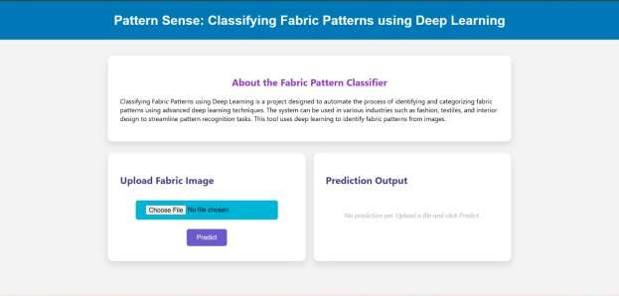The user interface is built using Flask and HTML. It allows users to upload Pattern Sense and view predictions. The interface includes a title, file upload button, prediction button, and displays the result along with team information and a thank-you message.

# Step-10:testing

The testing for this project was focused on verifying the accuracy and functionality of the Pattern Sense model and its integration with the Flask web interface.

# Testing Strategy:

* + **Model Testing**:
    - The dataset was split into training and testing sets.
    - The trained model was evaluated using the test images to check prediction accuracy.
    - Sample images were manually tested by uploading through the UI and verifying the predicted pattern sense.

# Interface Testing:

* + - The Flask web interface was tested by uploading various pattern images.
    - Verified whether the UI correctly accepted files and displayed the predicted output.
    - Checked behavior for invalid inputs (e.g., no file selected, wrong file type).

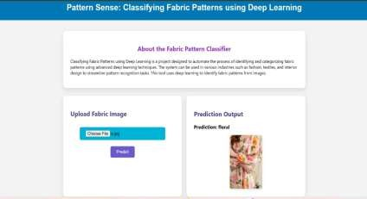



Step-11: Screenshots

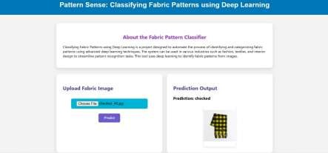

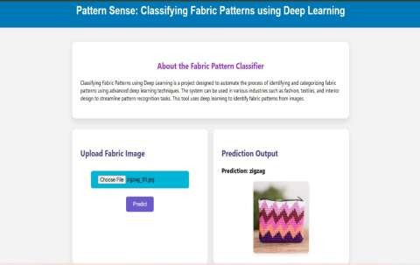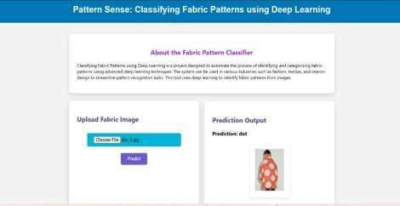

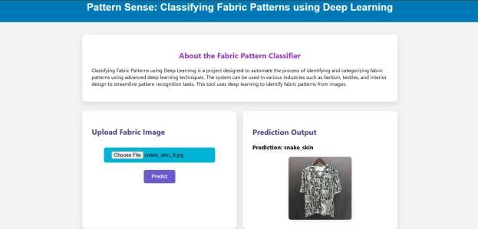

# Step-12. Known Issues

While the fabric pattern classification system performs well in most scenarios, the following limitations and known issues were observed during testing:

# Visually Similar Pattern Confusion:

Certain fabric patterns with subtle differences (e.g., stripes vs. pinstripes, abstract vs. floral) may be misclassified due to overlapping visual features.

# Imbalanced Dataset Impact:

The model may show bias towards pattern classes with more training examples, leading to lower accuracy for underrepresented categories.

# Lighting and Wrinkle Artifacts:

Images with uneven lighting, shadows, or folds in fabric can negatively impact prediction accuracy.

# Low-Resolution Image Limitations:

Small or blurry fabric images reduce the ability of the model to detect intricate patterns reliably.

# Step-13:Future Enhancements

* + **Deploy as a Web or Mobile Application** to make the tool accessible for designers, textile manufacturers, and end-users.
  + **Adopt More Advanced Architectures** such as EfficientNet or Vision Transformers to enhance classification accuracy.
  + **Expand Dataset with Diverse Fabric Types** to improve model generalization across various pattern styles and materials.
  + **Allow Batch Upload and Processing** for classifying multiple fabric samples in one go.
  + **Include Pattern Metadata and Use Cases** to provide users with additional context, such as design origin, cultural relevance, or typical usage in fashion or interiors.
  + **Introduce Real-Time Camera Input** for on-the-fly fabric classification during shopping or production inspection.